**2/12/2021**

**Superbowl Analytics**

**Lindsay Fielden, Zach Gabalson, Amy Ha, Daniel Ilott**

**Introduction**

With the support and sponsorship of FireToss, the University of Utah OIS Department, Molio, Layton Construction, and ThomasArts, for the fifth year in a row, the David Eccles School of Business is hosting a challenge to analyze Twitter tweets activity during the Super Bowl, to study the effectiveness of television ads run on game day.

Since 2017, brands have spent an average of at least $5 million for each 30 seconds of airtime during the Super Bowl.[1] This year, there were 56 advertisements, among which 25 advertised for the first time in the Super Bowl.[2] The average spend this year is $5.5 million, slightly lower than that of last year, which was $5.6 million.[3] Our aim is to gauge the effect of money, time, message and assets used on advertisements, and measure the return on this investment for brands. We do so by analyzing variables like number of tweets, keywords, hashtags, retweets, and unique users.

A total of 1,159,168 tweets were collected between 4:20 PM Sunday and 4:20 PM Monday on 15 virtual servers using Twitter Streaming and Query APIs. These tweets were gathered based on matches to predetermined keywords related to each brand.

**Infographic Metrics**

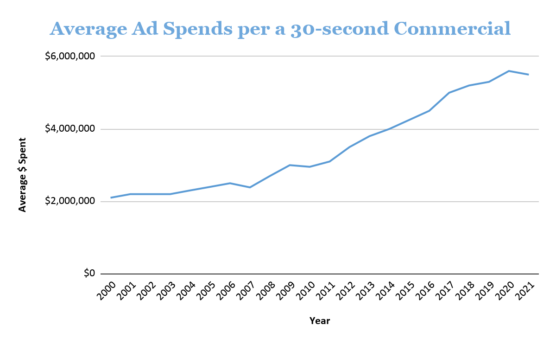

* **Year vs. Cost:** Find the average amount of money spent on a 30-second ad each year from 2000, to see how the cost to advertise during the Super Bowl has changed.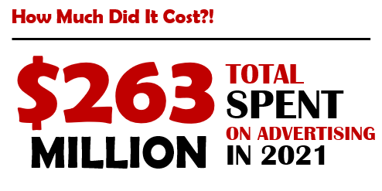
* **Top 5 Brands Most Mentioned and Least Mentioned Brands by Retweets**: Sum all retweets related to brands who aired one or more commercials during the Super Bowl broadcast and present top 5 brands and total tweet counts. The Top 5 Brands by this metric were: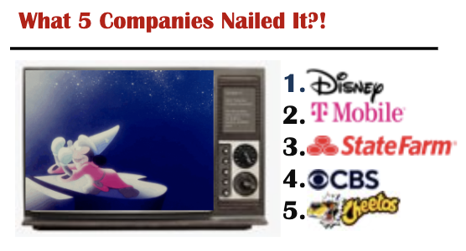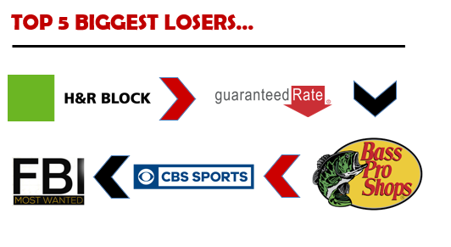
  + Most mentioned: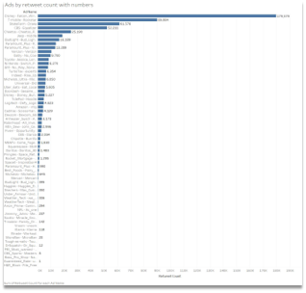
    - Disney - Falcon and Winter Soldier
    - T-mobile - Rockstar
    - Statefarm - Drake
    - CBS - Equalizer
    - Cheetos - Cheetos Farm
  + Least mentioned:
    - H&R Block
    - Guaranteed Rate
    - Bass Pro
    - CBS Sports
    - FBI Most Wanted

A majority of the analytics was performed using the Tableau program. Once the flattened zip folder of the Super Bowl 2021 tweets was uploaded to the program, the ‘Ad Name’ table was assigned to the Columns section. The group then decided it best to use the ‘Retweet Count’ to determine the most popular brands since after looking at the amount of data collected between the Retweet Count and the Favorite Count, the Retweet Count had more data to work with. Once the Retweet Count was added to the Rows section, and the graph was organized in descending order; the results became clear as to the least and most popular brands. While we only specified the top and bottom 5 brands in our Infographic, having all the brands listed in our chart in order of how successful they were is important information for any company.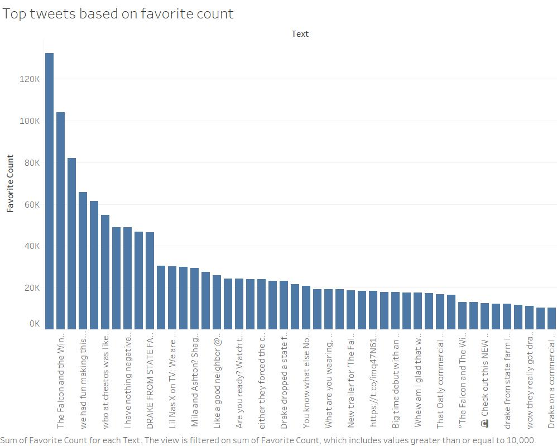

* **ROI (Return on Investment) Stats** 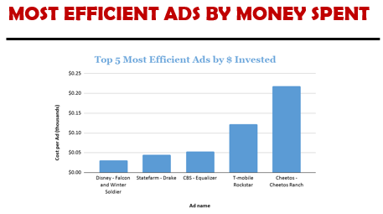
  + Cost per tweet = $ invested/tweet.

Dollars invested is calculated by taking the total time length of all commercials run by each brand, multiplied by an average of $5.5 million per a 30-second commercial. Top 5 brands with the highest ROI are:

1. Disney - Falcon and Winter Soldier | $30
2. Statefarm - Drake | $40
3. CBS - Equalizer | $50
4. T-mobile Rockstar | $120
5. Cheetos - It Wasn’t Me | $220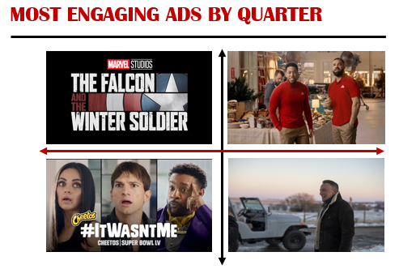

* **Total Tweets by Game Period**: Use MySQL to analyze Ad Name, Retweet Count and the Favorite Count. Sum all tweets related to brands who aired one or more commercials during the Superbowl broadcast and present total tweets distributed across each of 5 game broadcast periods: Quarter 1, Quarter 2, Quarter 3, Quarter 4. The top performer by tweets in each quarter:
  + Quarter 1: Disney - Falcon and Winter Soldier
  + Quarter 2: Statefarm - Drake
  + Quarter 3: Cheetos - It Wasn’t Me
  + Quarter 4: Jeep | The Middle

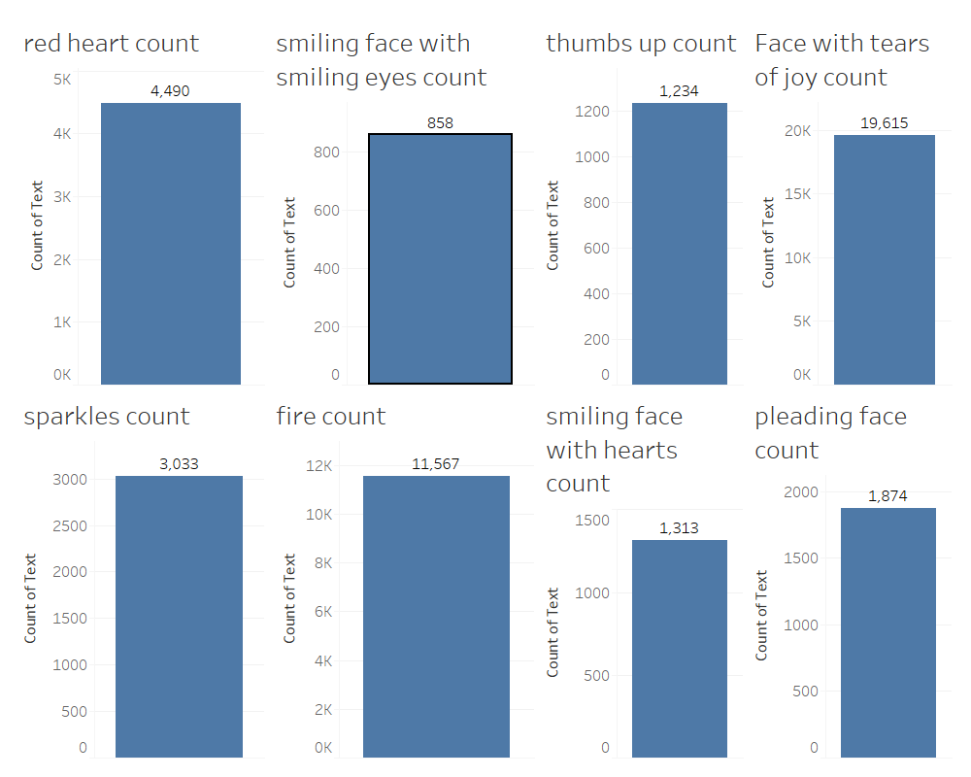

* **Top Emojis**: Since there are so many variations and types of emojis that can be used on Twitter’s posts it would be very difficult to figure out which emojis out of all possible emojis was the most used in the collectd Tweets. Instead, the team decided to base our findings off of [an article](https://emojipedia.org/twitter/) we found online that claimed to know the most popular emojis used on Twitter. To make the research even more interesting, we wanted to see who would have more used emojis in tweets, the website or us. To make sure the search would only pull up emojis used in the actual tweet, and not emojis that could have been used in user profile descriptions, we limited our search to looking at just the ‘Text’ section of the data. We then made for each emoji a data sheet to hold the count for the number of times the emoji was used. To find the total count we used the ‘Wildcard’ option in the filter to search for the emoji that was copied from Excel. Excel contains an entire list of emojis that match Twitter’s availability, making it easier to assure none of the emojis would be mixed up. Once all of the counts were gathered by using the ‘Measure>Count’ option, the Website’s guesses were combined into one view in a new dashboard, while our team’s guesses were gathered in another. We calculated the total for each team separately from the project to see how we did. Given how many tweets were collected in this project, Markalytics pulled ahead by a small 2,000 in emoji counts.
* **Number of Followers vs. Viral by Retweets:** Sum of retweet count vs. sum of followers count of tweets, to show if there is a correlation between the number of followers a Twitter account has and the viral of tweets they posted. 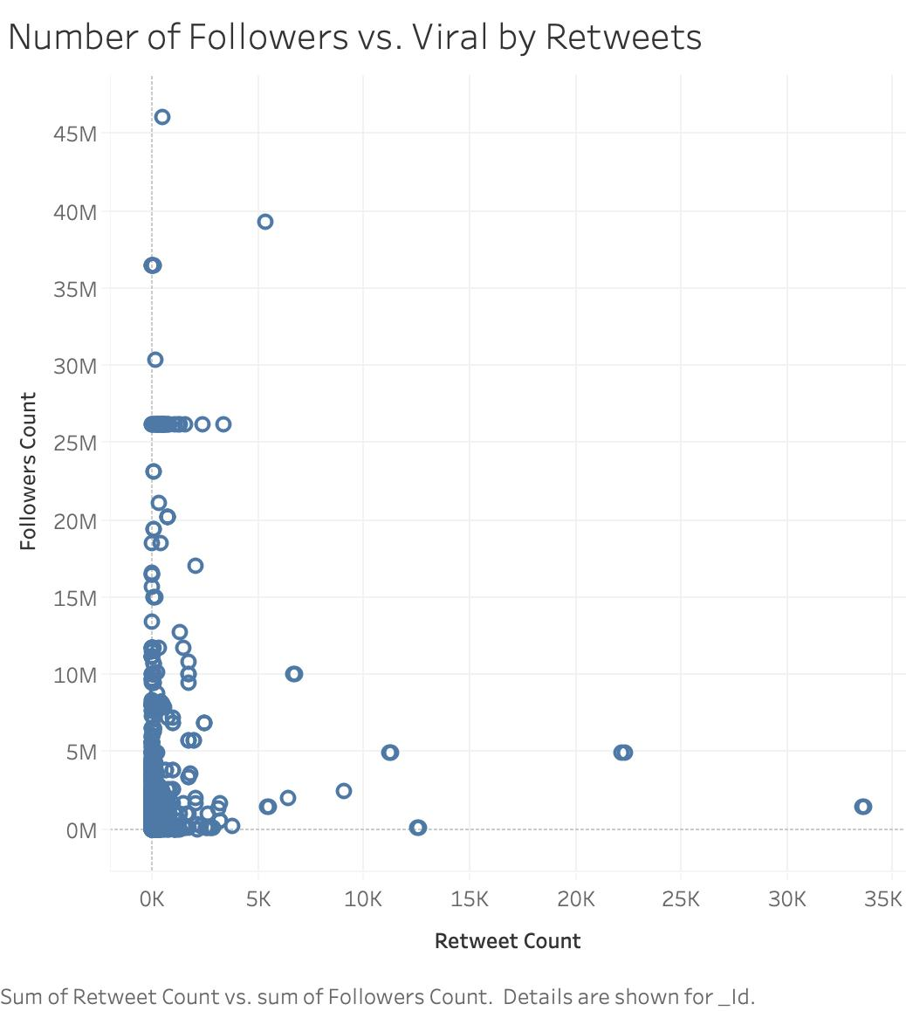

As shown in the graph, there is no strong correlation. Tweets from people with fewer followers got fewer retweets, but tweets from those with more followers didn’t necessarily get more retweets. Similarly, a few tweets from people with fewer followers got a significant number of retweets. Therefore, we conclude that brands or ads don’t need “high profile” accounts with many followers to tweet to become viral.

* **The Most Liked Tweets:** When it came to figuring out the most popular tweet from an individual user, we wanted to have the results based on the ‘Favorite Count’ since a majority of our study has been focused around ‘Retweet Count’. That, and consumers are more likely to like/favorite a friend or family member’s tweet then they are to retweet it. To focus on the tweets made by individual users, and to also prevent the program from crashing, we decided to stick with the ‘Text’ of the tweet, instead of trying to find the unique id associated with the tweet. This way, we could pull the content of the successful tweets directly, and see what they have in common right on the spot. We then narrowed our search to include tweets that had a minimum of 10,000 favorites. This would make it easier to view the top tweets, but also most companies only want to look at the most successful of the tweets. Anything below 10,000 favorites would not be worth analyzing, and would take too much time. 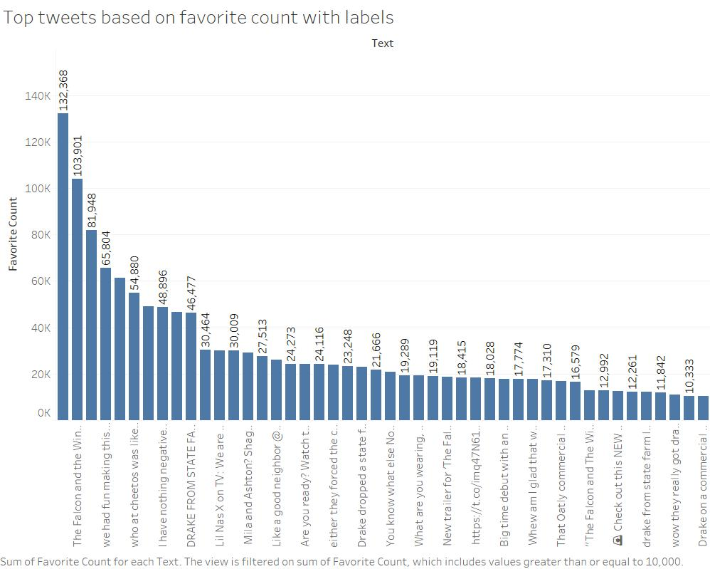
* **Ads by category:** Divide commercials into categories: Food/Beverage, Streaming/Movies, Physical Product, Service. Find out which ad was the most successful in its designated category based on Retweet count. 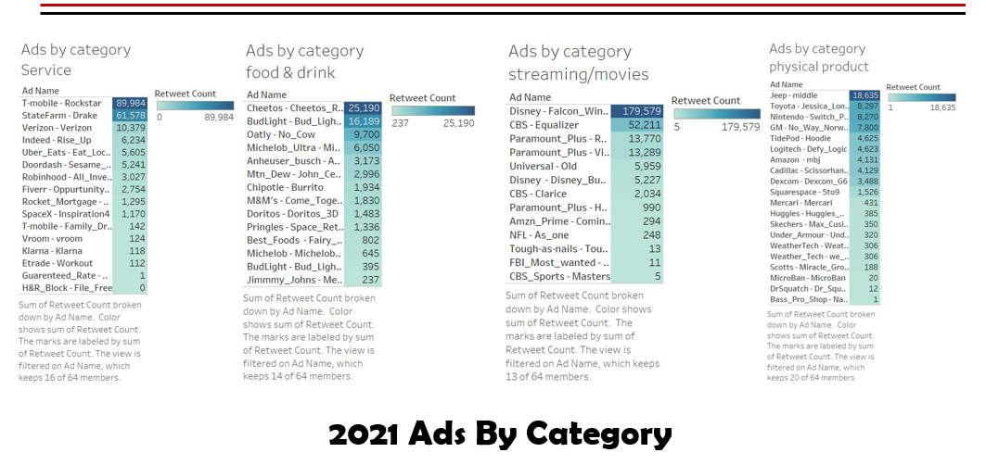

With the rise of streaming services being offered in this year alone, we thought it best that Streaming Services be placed in the same category as Movies. While Streaming in itself is a service, it is also a digital medium offering various Tv shows and movies to the public. It is for this reason we group Streaming and Movies together instead of having Streaming in the Services group. For Service, we wanted this group to specifically involve the provision of a service not digital media related. For example, T-mobile is offering to its customers the capability of upgrading their phones to 5g network towers. This is not media provision service, but rather an overall phone upgrade. This category also includes services offered through mobile applications and web browsers.

**Code for MySQL Database**

-- phpMyAdmin SQL Dump

-- version 5.0.2

-- https://www.phpmyadmin.net/

--

-- Host: 127.0.0.1:3306

-- Generation Time: Feb 12, 2021 at 03:21 AM

-- Server version: 5.7.31

-- PHP Version: 7.3.21

SET SQL_MODE = "NO_AUTO_VALUE_ON_ZERO";

START TRANSACTION;

SET time_zone = "+00:00";

/*!40101 SET @OLD_CHARACTER_SET_CLIENT=@@CHARACTER_SET_CLIENT */;

/*!40101 SET @OLD_CHARACTER_SET_RESULTS=@@CHARACTER_SET_RESULTS */;

/*!40101 SET @OLD_COLLATION_CONNECTION=@@COLLATION_CONNECTION */;

/*!40101 SET NAMES utf8mb4 */;

--

-- Database: `superbowl2021`

--

--

-- Dumping data for table `basicinfo`

--

INSERT INTO `basicinfo` (`time`, `quarter`, `ad`, `brand`, `keywords`, `kywords_lower`) VALUES

(446, '1', 'Old', 'Universal', 'Shyamalan Oldmovie~MNightShyamalan', 'shyamalan~oldmovie'),

(447, '1', 'Defy_Logic', 'Logitech', 'LilNasX DefyLogic logitech', 'lilnasx defylogic logitech'),

(447, '1', 'Come_Together', 'M&Ms', 'M&M DanLevy cometogether', 'm&m danlevy cometogether'),

(448, '1', 'Roll_Call', 'Paramount_Plus', 'Snooki JamesCorden StarTrek Beavis ButtHead ParamountPlus', 'snooki jamescorden startrek beavis butthead paramountplus'),

(452, '1', 'Falcon_Winter_Soldier', 'Disney', 'Marvel Falcon WinterSoldier SebastianStan AnthonyMackie', 'marvel falcon wintersoldier sebastianstan anthonymackie'),

(453, '1', 'Inspiration4', 'SpaceX', 'Inspiration4 spacex civilianmission', 'inspiration4 spacex civilianmission'),

(453, '1', 'Sesame_Street', 'Doordash', 'BigBird Theneighberhood SesameStreet doordash Daveeddiggs', 'bigbird sesamestreet doordash daveeddiggs'),

(501, '1', 'Doritos_3D', 'Doritos', 'doritos3d matthewmcconaughey Iwanttobreakfree MindyKaling flatmatt flatmatthew', 'doritos3d matthewmcconaughey iwanttobreakfree mindykaling flatmatt flatmatthew'),

(502, '1', 'No_Way_Norway', 'GM', 'WillFerrel KenanThompson Norway EverybodyIn NoWayNorway ultiumbattery Akwafina', 'willferrel kenanthompson norway everybodyin nowaynorway akwafina'),

(503, '1', 'Hooked_It', 'Paramount_Plus', 'StarTrek paramountmountain BrysonDeChambeau spok', 'startrek paramountmountain brysondechambeau spok'),

(511, '1', 'Space_Return', 'Pringles', 'Pringles', 'pringles'),

(512, '1', 'Bud_Light_Legends', 'BudLight', 'BudLight PostMalone BudLightLegends', 'budlight postmalone budlightlegends'),

(513, '1', 'Burrito', 'Chipotle', 'Chipotle ForReal Canaburritochangetheworld', 'chipotle forreal canaburritochangetheworld'),

(516, '2', 'John_Cena', 'Mtn_Dew', 'JohnCena LifeChangingFlavor MTNDEWMajorMelon', 'johncena lifechangingflavor mtndewmajormelon'),

(517, '2', 'Dexcom_G6', 'Dexcom', 'NickJonas Fingersticks Dexcom dexcomg6 diabetes', 'nickjonas fingersticks dexcom dexcomg6 diabetes'),

(518, '2', 'Rise_Up', 'Indeed', 'indeed Wehelppeoplegetjobs', 'indeed wehelppeoplegetjobs'),

(519, '2', 'Drake', 'StateFarm', 'Jakefromstatefarm Drake StateFarm', 'jakefromstatefarm drake statefarm'),

(529, '2', 'Bud_Light_Seltzer', 'BudLight', 'BudLightSeltzer RainingLemons Seltzerlemonade LemonsintoLemonade', 'budlightseltzer raininglemons lemonsintolemonade'),

(530, '2', 'Miracle_Grow', 'Scotts', 'MarthaStewart JohnTravolta LeslieDavidBaker MiracleGros ellatravolta', 'marthastewart johntravolta lesliedavidbaker ellatravolta'),

(530, '2', 'Max_Cusion', 'Skechers', 'maxcushioning Skechers', 'maxcushioning skechers'),

(531, '2', 'WeatherTech', 'WeatherTech', 'WeatherTech', 'weathertech'),

(531, '2', 'Equalizer', 'CBS', 'QueenLatifah TheEqualizer cbs', 'queenlatifah theequalizer cbs'),

(538, '2', 'Tracy_Morgan', 'Rocket_Mortgage', 'TracyMorgan DaveBautista RocketMortgage', 'tracymorgan davebautista rocketmortgage'),

(539, '2', 'No_Cow', 'Oatly', 'TonyPeterson Oatly NoCow', 'oatly nocow'),

(540, '2', 'Huggies_Diapers', 'Huggies', 'Huggies Wegotyoubaby', 'huggies wegotyoubaby'),

(540, '2', 'Masters', 'CBS_Sports', 'TheMasters', 'themasters'),

(548, '2', 'Jessica_Long_Upstream', 'Toyota', 'TeamUSA Toyota JessicaLong', 'teamusa toyota jessicalong'),

(549, '2', 'Workout', 'Etrade', 'Etrade', 'etrade'),

(550, '2', 'Fairy_God_Mayo', 'Best_Foods', 'AmySchumer Bestfoodsmayo hellmansmayo fairygodmayo', 'amyschumer hellmansmayo fairygodmayo'),

(556, '2', 'experts', 'TurboTax', 'theexpertsarecoming Turbotax', 'turbotax'),

(557, '2', 'Mercari', 'Mercari', 'Mercari yourmarketplace', 'mercari yourmarketplace'),

(557, '2', 'Hoodie', 'TidePod', 'TideHoodie Tide JasonAlexander', 'tidehoodie tide jasonalexander'),

(602, '2', 'Dr_Squatch_soap', 'DrSquatch', 'DRSquatch yourenotadish', 'drsquatch yourenotadish'),

(602, '2', 'vroom', 'Vroom', 'vroom switchtovroom', 'vroom switchtovroom'),

(603, '2', 'Meet_the_King', 'Jimmmy_Johns', 'JimmyJohns Thesandwichofsandwiches meettheking BradGarrett Tonybolognavich', 'jimmyjohns thesandwichofsandwiches meettheking bradgarrett tonybolognavich'),

(604, '2', 'Rockstar', 'T-mobile', 'GwenStefani AdamLevine BlakeShelton Tmobile leaderin5g', 'gwenstefani adamlevine blakeshelton tmobile leaderin5g'),

(618, '2', 'Victory', 'Paramount_Plus', 'StephenColbert PatrickStewart JamesCorden Spongebob Beavis Butthead', 'stephencolbert patrickstewart jamescorden spongebob beavis butthead'),

(620, '3', 'As_one', 'NFL', 'InspireChange saytheirstories', 'inspirechange saytheirstories'),

(651, '3', 'Verizon', 'Verizon', 'SamuelLJackson Verizon JUJUSmithSchuster', 'samuelljackson verizon'),

(652, '3', 'Eat_Local', 'Uber_Eats', 'WaynesWorld EatLocal CardiB ubereats', 'waynesworld eatlocal cardib ubereats'),

(659, '3', 'Family_Drama', 'T-mobile', 'AnthonyAnderson teamAnthony teammama', 'anthonyanderson teamanthony teammama'),

(700, '3', 'Michelob_Ultra', 'Michelob_Ultra', 'AnthonyDavis SerenaWilliams', 'anthonydavis serenawilliams'),

(706, '3', 'MicroBan', 'MicroBan', 'Microban', 'microban'),

(706, '3', 'Oppurtunity_Knocks', 'Fiverr', 'Fiverr FourSeasonsTotalLandscaping NotAHotel OpportunityKnocks', 'fiverr fourseasonstotallandscaping notahotel opportunityknocks'),

(713, '3', 'Coming2America', 'Amzn_Prime', 'EddieMurphy Coming2America', 'eddiemurphy coming2america'),

(714, '3', 'Cheetos_Ranch', 'Cheetos', 'Ashtonkutcher MilaKunis Shaggy CheetosCrunchPopMix Cheetos', 'ashtonkutcher milakunis shaggy cheetoscrunchpopmix cheetos'),

(715, '3', 'we_never_left', 'Weather_Tech', 'WeatherTech weneverleft', 'weathertech weneverleft'),

(715, '3', '5to9', 'Squarespace', 'Squarespace dollyparton 5to9', 'squarespace dollyparton 5to9'),

(723, '3', 'Under_the_Armour', 'Under_Armour', 'MichaelPhelps openyoureyes underarmour', 'michaelphelps openyoureyes underarmour'),

(724, '3', 'Switch_Play', 'Nintendo', 'Nintendo NintendoSwitch AnimalCrossing', 'nintendo nintendoswitch animalcrossing'),

(724, '3', 'File_Free', 'H&R_Block', 'H&RBlock', 'h&rblock'),

(725, '3', 'Clarice', 'CBS', 'Silenceofthelambs Clarice', 'silenceofthelambs clarice'),

(729, '4', 'Scissorhands', 'Cadillac', 'Edgar TimotheeChalamet Cadillac edgarscissorhands', 'edgar timotheechalamet cadillac edgarscissorhands'),

(730, '4', 'Anheuser_Busch', 'Anheuser_busch', 'MichelobUltra anheuserbusch LetsGrabABeer', 'michelobultra anheuserbusch letsgrababeer'),

(739, '4', 'middle', 'Jeep', 'Themiddle reunitedstates roadahead jeep BruceSpringsteen', 'themiddle reunitedstates roadahead jeep brucespringsteen'),

(748, '4', 'Michelob_Seltzer', 'Michelob', 'DonCheadle MichelobUltraSeltzer', 'doncheadle michelobultraseltzer'),

(749, '4', 'Disney_Bundle', 'Disney', 'Hulu DisneyBundle', 'hulu disneybundle'),

(750, '4', 'Klarna', 'Klarna', 'Klarna mayarudolph', 'klarna mayarudolph'),

(750, '4', 'Nature', 'Bass_Pro_Shop', 'getbacktonature bassproshop', 'getbacktonature bassproshop'),

(751, '4', 'Most_wanted', 'FBI_Most_wanted', 'FBIMostwanted', 'fbimostwanted'),

(755, '4', 'All_Investors', 'Robinhood', 'Robinhood', 'robinhood'),

(756, '4', 'Tough-as-nails', 'Tough-as-nails', 'ToughasNails PhilKeoghan', 'toughasnails philkeoghan'),

(806, '4', 'mbj', 'Amazon', 'MichealBJordan Alexa', 'michealbjordan alexa'),

(807, '4', 'underdog', 'Guarenteed_Rate', 'Beliveyouwill GuarenteedRate DustinPorier RyanNewman ErikWeihenMayer', 'guarenteedrate dustinporier erikweihenmayer');

COMMIT;

/*!40101 SET CHARACTER_SET_CLIENT=@OLD_CHARACTER_SET_CLIENT */;

/*!40101 SET CHARACTER_SET_RESULTS=@OLD_CHARACTER_SET_RESULTS */;

/*!40101 SET COLLATION_CONNECTION=@OLD_COLLATION_CONNECTION */;

1. <https://www.sportingnews.com/us/nfl/news/super-bowl-commercials-cost-2021/o496m61j4lkn19kxoygv9690a>
2. <https://www.adweek.com/brand-marketing/every-super-bowl-55-ad-in-under-two-minutes/>
3. <https://www.adweek.com/brand-marketing/super-bowl-lv-ad-tracker-2021-commercials/>